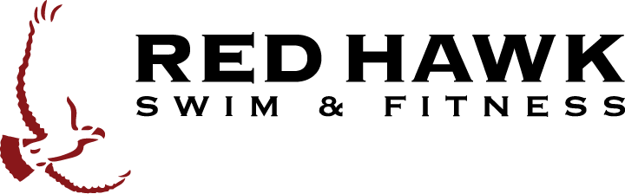
Private $225 (Member) $250 (Non Member)
Semi Private $175 (Member)/$200 (Non Member)
Each session includes (5) 25-min lessons
Lessons Registration Form
775-626-8699
bluque@resortatredhawk.com

Participant’s Name | DOB | Sex | Dates | Time | Fee
TOTAL FEE

Adult Name
 | First |  |  | Last |  | SF Number
Address
 | Street |  | City |  | State |  |  | Zip
Phone | ( ) ( )
 | Primary | Secondary |  |  |  |  | Email address
Cancellation policy: The parent/guardian assumes responsibility to ensure the participant listed above attends all scheduled swim classes in their registered session. Cancellations must be made 5 business days prior to session start date to receive a full refund. No Prorated refunds for left over lessons. No refunds or make up classes will be given for tardy or missed classes. Classes may be cancelled and rescheduled due to poor weather or poor air quality. Any rescheduling must be made within 48 hours of the class.
RED HAWK SWIM & FITNESS CENTER
GENERAL RELEASE, WAIVER, AND INDEMNITY AGREEMENT
In consideration of my minor child, , being permitted to participate in a swim program at the Red Hawk Swim & Fitness Center, the undersigned, for myself, my spouse and on behalf of my minor children, release, waive, and covenant not to sue RED HAWK LAND COMPANY, LLC, its owners, members, managers, officers, directors, shareholders, allied entities, employees, or agents (collectively, “RED HAWK”), with respect to any and all claims or causes of action that I or my child may have or which may hereafter accrue to my child or me on account of injury to his/her person or property, whether caused by the negligence of RED HAWK or otherwise, as a result thereof.
This release is intended to discharge RED HAWK from all liability arising out of or connected in any way with my minor child’s participation in the aquatic swim program at Red Hawk. I hereby agree to assume all risks, both known and unknown, associated with or arising out of my minor child’s participation in such program, and to release RED HAWK even though it might (through negligence or carelessness) otherwise be liable to my child (or his/hers or assigns).
The undersigned, on behalf of myself, spouse and my minor child, agrees to indemnify RED HAWK and save RED HAWK harmless from loss, liability, damage, or cost it may incur due to or arising out of the activities provided for hereunder or my child’s participation in or proximity to any activities thereon, whether caused through his/her negligence or otherwise. This indemnification includes legal defense of any such claims by whoever made (using legal counsel reasonably satisfactory to RED HAWK), reasonable attorneys’ fees and costs, and the cost of any settlement or judgment.
I hereby grant and convey unto Red Hawk Swim and Fitness Center the right to freely reproduce and/or circulate any photographs or other recordings of me during my participation in the Activities for any lawful purpose. I agree that I shall not be entitled to any compensation therefore, including, but not limited to, any royalties, proceeds, or other benefits derived from such photographs or recordings.
THE UNDERSIGNED HAS READ, UNDERSTANDS, AND VOLUNTARILY SIGNS THIS GENERAL RELEASE, WAIVER, AND INDEMNITY AGREEMENT, BEING FULLY AWARE OF THE IMPORTANT LEGAL CONSEQUENCES OF SO DOING. THE TERMS OF THIS DOCUMENT ARE CONTRACTUAL AND NOT A MERE RECITAL.
Name of Minor Child: Signature of Parent or Guardian:_______________________________________ Date:_________________________

Method of Payment
Card Number_____________________________________Expiration___________Card Type___________________________ Signature______________________________________Amount__________________________________Billing Zip________

